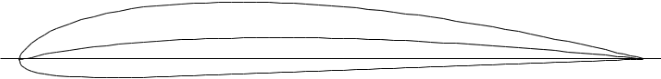

Name = CLARK Y AIRFOIL

Chord[PoweredbyTCPDF(www.tcpdf](http://www.tcpdf.org)=[.org)](http://www.tcpdf.org) 90mm Radius = 0mm Thickness = 100% Origin = 0% Pitch = 0°